Plumbing Basics
Essential Question: Where does my water come from and where does it go?
Discipline: Construction Trade / Plumbing / Fluids (for the general homeowner)
Goal: Identify key components of basic plumbing systems and how to maintain good fluid flow.
Level: Basic to Intermediate
Time: 30 - 40 minutes
Video Links: Water Shut Off Valve: https://www.youtube.com/watch?v=RvE6n7rTGnM
What’s Under Your Sink: https://youtu.be/mxtHgsob6mM
Activity Procedures
At the end of this project, students should be able to: Understand how to turn off a main water valve to a residence.
- "Watch video on how where to find water shut off valve: https://www.youtube.com/watch?v=RvE6n7rTGnM.
- With an adult, find the valve and take a picture (embed this photo in an email with your answers/thoughts to the tasks below and send to your instructor).
- After watching the video: https://youtu.be/mxtHgsob6mM, please take 5-10 minutes to look around your house/apartment (with your parents’ permission) to look under the sink at multiple location (i.e. bathroom, laundry room).
- Review the two diagrams on the next page to “see what’s in the walls.”
- Next, record some key observations in your email.
- If a plumbing fixture in the bathroom break and starts leaking? Do you know how to shut off the incoming water to that fixture?
- When looking under the sink, did you notice any water or leaks that should not be there? Take some time to problem solve this with an adult if you notice something.
- If safe to do so, go outside and identify the roof vents that come up through the walls and through the roof. Take note of the roofing strategy and method around vents on your roof.
- Now, please help your parent/guardians by cleaning your bathroom or other water/sink areas (optional: take a before and after photo and notice your great work!).
- Email your instructor proof of this activity from steps 2, 5, 6, 7, 8, 9.
- Thanks for learning about your residence. Stay healthy and safe!
Diagram 1 – What is Under the Sink
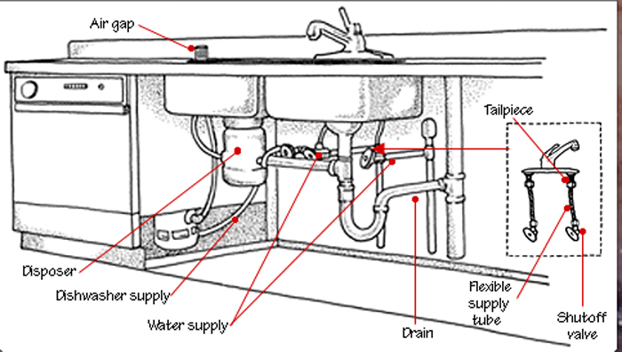
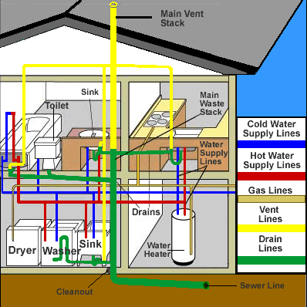
Diagram 2 – What is in the Walls

