Building Construction Class
Any level 1+ hour

Door Handing Activity

- Research 4 door handing terms for single swing doors (meaning the door swings only one direction). These terms apply to double doors or “French” doors as well. Teacher can determine how many online sources students consult or direct students to particular websites or resources (e.g. Career Connections Residential Construction book, unit 9, chapter 1: Doors).
- Right Hand
- Left Hand
- Right Hand Reverse
- Left Hand Reverse
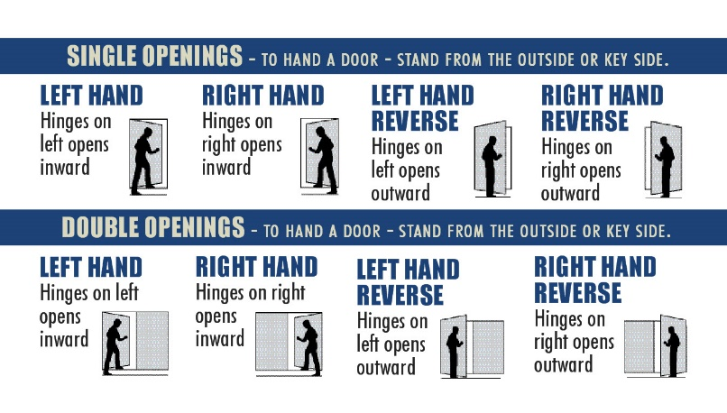
- Students identify the hand of all interior and exterior swinging doors in their home. If the door doesn’t swing, let’s say it slides or folds, students can use this Door Blue Print pic to identify the type of door.
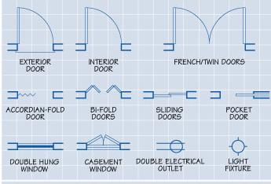

Documentation Ideas
Students could email teacher a pic of themselves in front of 3 doors and call out the swing, make a video of themselves in front of a door explaining the swing or make a short google slideshow with the photos.

Add Challenge
Students could do a scale drawing of their living space and draw all door symbols to match swing/style of the doors.

