Project #6
The Doghouse

This is the project students tend to think is the most fun. It is also the project that hurts many students’ grades because they can “get away” with not doing a single thing for two weeks. This is because it is a group project and the motivated students tend to find themselves doing all the work. But that’s okay, because in the end, you as an individual grade each other confidentially. So feel free to let those that will just ride along, because in the end it will be accounted for. This is a word of caution for you unmotivated folks.
Just like on a regular house, we start with the support. Underneath the floor there are joists that run across the length of the house. One nail to each side of a joist and stud. Follow the blueprints accurately, ask if you get stuck, be safe, and have fun!
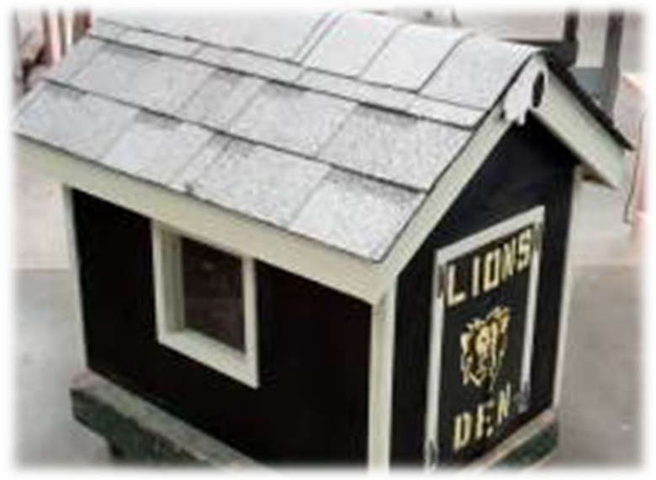

Joists
1. Make a list of joist lengths needed (wait on blocking) for entire Joist System
2. Set up cutting jig on Chop saw for repeated cut lengths
3. Cut all joists to desired lengths
4. Place top and bottom plates together and put a mark every 8” (8, 16, 24… etc.)
4. Without nailing, arrange all pieces according to plans (8” on center)
5. Total measurements should equal 23” by 35”
6. Either calculate or measure between joists for blocking lengths, then cut them
7. Re-align pieces and then began nailing blocking to joists from the inside out
8. Remember to brace whatever you are nailing against the table to increase nailing force

Subfloor
1. The plywood is cut square! Align one long rim joist to long edge of plywood
2. Hammer 4 nails into rim joist (make sure to center nails between joists to avoid splitting)
3. Square up the rest of your framing aligned to subfloor plywood and repeat nailing
4. Snap a chalk-line on plywood aligned with each joist (use nails as a reference)
5. Nail each joist with two nails averaged equally apart (including short rim joists)
Wall Framing
1. Set up jig for common stud lengths and cut as many needed for each wall (nail plates require 2 studs nailed with 2 nails averaged equally apart in an “L” shape). Cut double top plates in next stage
2. Center both window and door in walls before marking studs on plates
3. Again, mark top and bottom plates every 8”, then align all studs and nail together
Wall Assembly
1. Place front and back walls on subfloor (centered and flush with edge)
2. Nail bottom plate approximately 2” away from each stud on back wall. Use a nail gun for front plate
3. Place side walls on (align nail-plates to the inside) and nail next to studs again
4. Nail nail-plates to front and back walls with two nails horizontally for each nail-plate
5. Cut Double-top plates (32” and 23”) and nail on approximately 2” away from each stud again

Siding
1. The siding is cut square. Turn dog house on its side and put stud marks on top and bottom of doghouse
2. Align siding (rough side out) centered with the top edge of the house. ONLY nail in the top edge with 4 or 5 smaller nails.
2. Your framing is not square, square-up framing to match siding and nail bottom edge similarly
3. Snap a chalk-line between stud marks and nail twice on each stud equally apart
4. Repeat for all other walls.
Routering
1. Mark door and window on exterior of siding
2. Use plunge router and cut openings in a clockwise motion
3. Save cut-outs for later
Painting
1. Use a roller or a paint brush to paint the doghouse siding and trim
2. The paintbrush needs paint on only the bottom 1” of it. Use a tray for a roller, and the paint can for the brush.
3. Place scrap wood under the doghouse and on top of butcher paper so you can paint all the way to the bottom of the doghouse using the roller.
4. Remember to paint your rake edge siding at this time also, and the edges of your trim as well.
Rafters
1. Use rafter template and trace out 8 common rafters and 4 barge rafters
2. Use the chop saw to cut your plumb cuts and the band saw for the birds-mouth
3. Put marks on the double top plate every 12” starting from the front of the doghouse
4. Align common rafters with 12” marks
5. Use 16g air nailer to nail rafters to double top plate. Nail once in the back and once into each seat-cut, toe-nailed. End rafters should be flush with doghouse siding and nailed only towards the inside.
6. Cut ridge-rafter to 38 ½” long
7. Let the ridge-rafter overhang the doghouse equally on each end and duplicate rafter marks onto it
8. Lifting from the inside up, raise the ridge-rafter to align with rafters
9. Toe-nail rafters through kiddy corner of ridge-rafter (nail end rafters only towards the inside).
10. Using a nail-set, set each nail that protrudes on the rake ends of your doghouse.
Fascia
1. With given fascia material, copy steps 6 and 7 in the previous section.
2. Using the 16g air nailer, shoot 2 nails into each rafter-tail at the same angle as the pitch of the roof. Make sure that the top of the fascia is aligned flush with top edge of the rafters.
Rake edge siding and Barge Rafters
1. Rake edge siding will be given to you as a rectangle that must be cut into a pyramid shape. Center your rectangle on the doghouse and place a mark on it where it lines up with the ridge-rafter. Cut a small rectangle out of your siding at that point that is ¾ “ wide and 1 ½” deep.
2. Re-position your rectangle so that the cut-out on your siding slides over the ridge-rafter
3. Level your rake edge siding by eye before nailing!! Have some stand 20’ away to help you adjust it.
4. Using the pin nailer or air-stapler attach rake edge siding with 5 nails into the top plates and 3 into each rafter.
5. Center barge rafters on ridge rafter and mark them flush at edge of the fascia.
6. Cut barge rafters to marked length and attach with the 16g air nailer. Two nails at each end.
Roof Sheeting
1. The sheeting is cut square. Align beveled edge of sheeting flush with the fascia and use the air nailer/stapler to nail 5 times. Make sure the gun is pointing straight down into the fascia.
2. Adjust ridge-rafter so that it is centered with the sheeting and nail once into the top of each rafter.
3. Use a chalk line or straight-edge to mark all the rafters and nail twice more into each rafter.
Felt and Roofing shingles
1. Cut out a section of felt paper that is at least 40” long.
2. Attach felt to the doghouse roof so that it over/under-hangs evenly on all sides with stapler.
3. Trim excess felt
4. Find at least 10 shingles of your preference and 4 for hip and ridge material
5. Cut two shingles at the joint mark lengthwise from end to end. Save both pieces.
6. Use the unattractive piece upside down as starter course, centered, and hanging over the fascia ¾”
7. Nail onto the sheeting using two ¾” to 1” roofing nails.
8. Cut another shingle perpendicular, at least 10” from one end.
9. Using the longer of the two pieces, overhang it ¾” on the rake edge and flush with the starter course
10. Nail into place in the prescribed area with three to four 1” or larger nails.
11. Cut new sheet measured from the edge of that shingle to the far end of the doghouse plus ¾.”
12. Repeat step #10
13. Using leftover material in step #8, repeat steps #9 - #11, but keep bottom edge flush with aesthetic edge of first row.
14. Using leftover material in step #5, repeat step #13, using obvious adjustments as needed.
15. Cut hip and ridge (ridge-cap) from 3-tab shingles and start from front edge of doghouse.
Trim and window
1. There are 3 different sizes of trim. Pay attention to what you are using, as you only have enough for using the prescribed sizes.
2. The 2” material is for the inside edge of the door. The 1 ¼” material is for the front and back of the doghouse and the exterior trim around the window. The 1” material is for the inside edges of the window and the sides of the doghouse.
3. First cut the 1” material to the window width and nail on the top and bottom with two finish nails, flush with the inside edge of the doghouse. Repeat for the sides.
4. Install window
5. Repeat step #3 for outside edge of window
6. Use similar methods for inside door trim.
7. Cut 1” material to same length as siding and align flush with front and back of dog house on the sides
8. Install final 1 ¼” material. Use miter 45 degree cuts around window and door.
Emblem
1. The emblem goes over the barge rafters to hide the plumb cut. Cut any (g-rated) shape out of your leftover routered door or window siding and install on front and back.
Touch up
1. Touch up any paint defects and/or nail heads, etc.

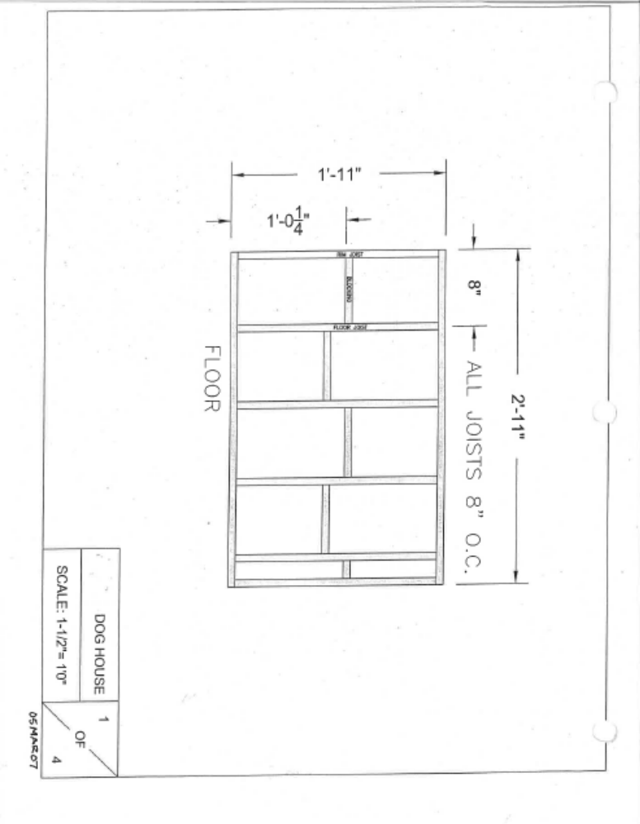

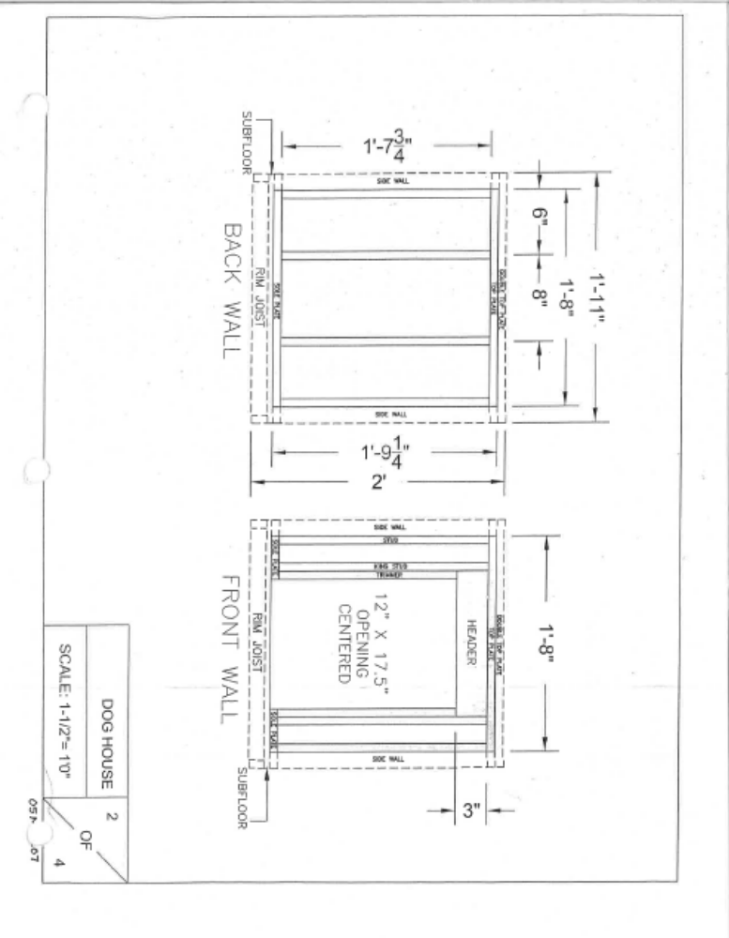

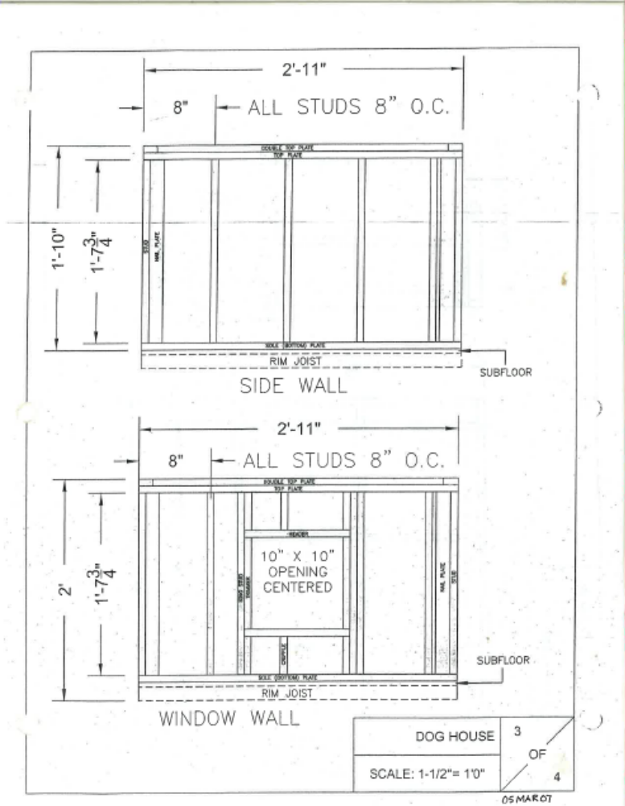

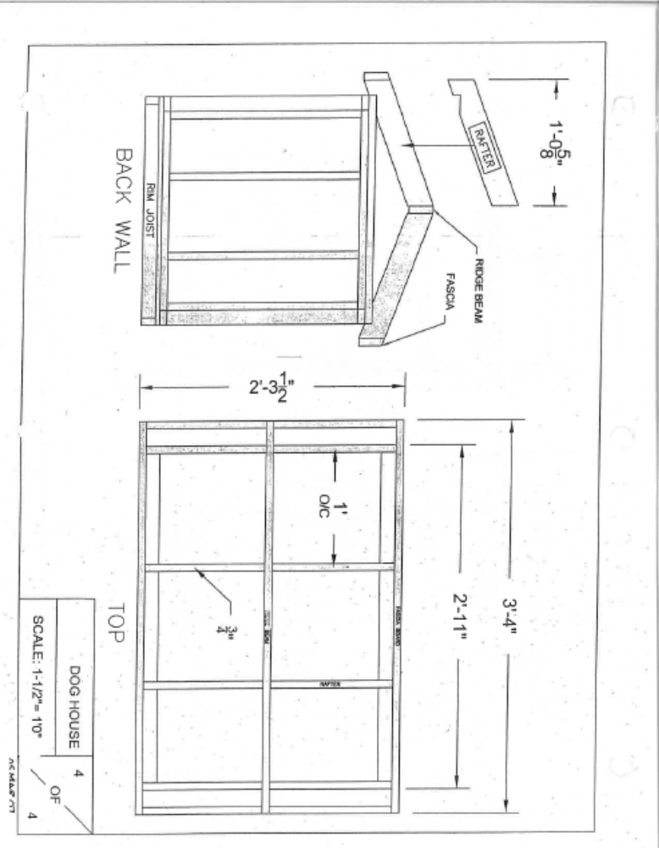

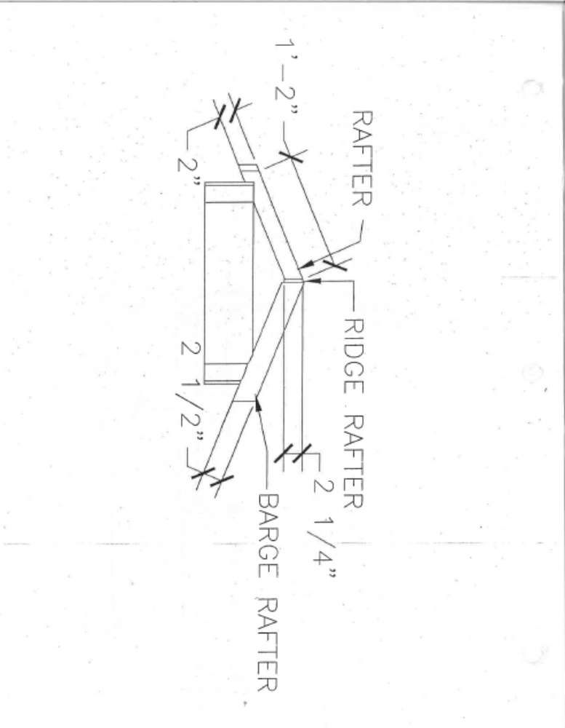

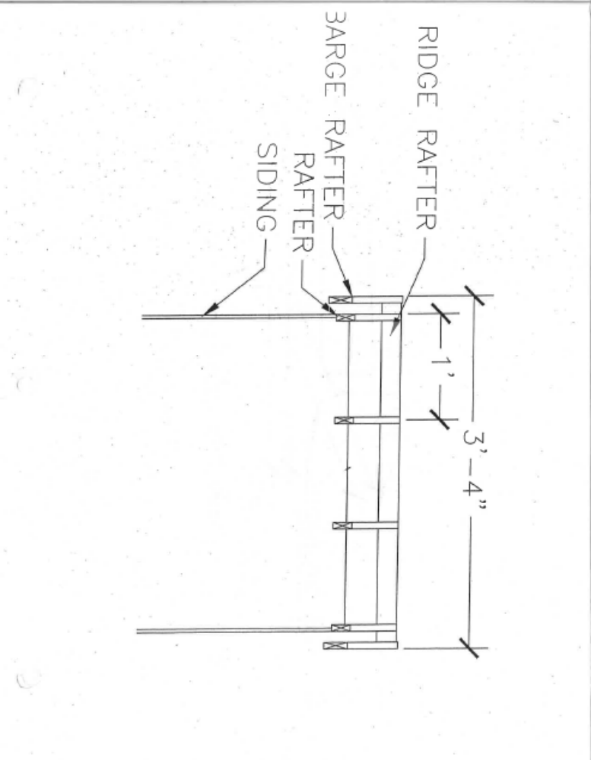


St Helens High School
Building Construction
Mr. Mauck
Doghouse Cost Sheet
Name: Period: Date:
Outcome: Student will be able to accurately calculate the cost of a doghouse using ratios, multiplication, and division.
Material list:
Description / Size | Amount of Material | Cost per unit | Ratio | Cost
Floor framing 1 ½ X ¾ | 220 in | 500 in = $5
Wall framing 1 ½ X ¾ | 920 in | 500 in = $5
Subfloor | 6 sq ft | 32 sq ft = $12
Siding | 20 sq ft | 32 sq ft = $16
Roof Framing 2 ¼ X ¾ | 350 in | 2048 in = $25
Trim 1 ½ X 3/16 | 450 in | 3100 in = $8
Window | 20 sq in | 5800 sq in = $120
Roofing | 10 shingles | 12 sh = $30
 |  |  | Total Cost =

Dog House Grading Sheet
Name: Group #________ Period: Date:
Write a check beside the person’s name(s) who did the majority of each section
If you do not remember, leave the space blank
Names →
Subfloor
Door wall
Window Wall
Rear wall
Blank wall
Exterior Siding
Window & Door Routering
Siding Painting
Rafter Nailing
Roof Sheeting Stapling
Roofing Shingles Nailing
Trim painting
Trim installing
In the final row, give a final grade for each group member, including yourself
Please remember that you will be doing a dishonor to both you and your partners if you do not accurately reflect their grade
Final Grade
(A+ to F-)
What grade do you think the overall quality of your doghouse deserves? (A+ to F-)

